Purpose Statement
Eliminate the admission document verification bottleneck by automating 70% of manual document checks, enabling the institution to process 3x more applications during peak season without additional staff.

🎯 Detailed Purpose Breakdown

1. PRIMARY BUSINESS PROBLEM
The Pain Point: During admission season, Serosoft's Education ERP clients face a critical bottleneck:
- Manual verification of 8-10 documents per student (marksheets, certificates, ID proofs)
- 15 minutes per application for document review
- Peak season overload: 5,000+ applications in 30 days
- Limited staff: 5-6 admission officers available
- Result: 2-3 week backlogs, frustrated students, staff burnout, admission cycle delays
Direct Impact on Business:
- Lost Revenue: Delayed admissions mean late fee collection, lost interest income
- Reputation Damage: Students complain on social media about slow responses
- Competitive Disadvantage: Other colleges offering faster admission decisions win students
- Operational Cost: Need to hire temporary staff during peak season (₹3-5 lakhs extra cost)

2. WHAT THE SOLUTION DOES
Core Functionality: Automated AI system that:
✅ Extracts data from uploaded documents using OCR (Azure Form Recognizer) ✅ Validates authenticity by checking document patterns, signatures, formats ✅ Cross-verifies information across multiple documents (name, DOB, marks match) ✅ Checks eligibility against admission criteria stored in knowledge base (RAG)
Technology Stack:
- Azure OpenAI (GPT-4): Intelligent reasoning and verification logic
- RAG (Retrieval Augmented Generation): Access to admission policies, board formats, eligibility rules
- Azure Form Recognizer: OCR for document text extraction- We can use XAI for cost saving
- Vector Database (ChromaDB): Storage for institutional knowledge
- LangChain: Orchestration framework

3. SPECIFIC IMPACT & METRICS

A. Time Reduction: 40% Manual Review Time Saved
Before Implementation:
Average Application Processing:
- Document upload: 2 min (manual)
- Document verification: 15 min (manual)
- Eligibility check: 3 min (manual)
- Total: 20 minutes per application

With 5 staff members:
- Daily capacity: 5 × 8 hours × 3 apps/hour = 120 applications/day
- Monthly capacity: 120 × 20 working days = 2,400 applications/month
After Implementation:
Automated Application Processing:
- Document upload: 2 min (manual - unchanged)
- Document verification: 2 min (AI automated - 87% reduction)
- Eligibility check: 30 sec (AI automated - 83% reduction)
- Human review (only 30% of cases): 4 min
- Total: 9 minutes per application (40% reduction)

With same 5 staff members:
- Daily capacity: 5 × 8 hours × 5 apps/hour = 200 applications/day
- Monthly capacity: 200 × 20 working days = 4,000 applications/month
Key Metric Explained:
- 40% reduction in manual review time = Time per app reduced from 15 min to 9 min
- This translates to 67% increase in throughput (from 2,400 to 4,000 apps/month)

B. Additional Measurable Impacts
Impact Area | Before AI | After AI | Metric
Processing Speed | 15 min/application | 9 min/application | 40% faster
Daily Throughput | 120 applications | 200 applications | 67% increase
Error Rate | 10-12% | 2-3% | 75% reduction
Staff Utilization | 100% on verification | 30% on exceptions only | 70% freed up
Peak Season Backlog | 2-3 weeks | Real-time processing | Zero backlog
Fraud Detection | 60% catch rate | 95% catch rate | 58% improvement
Student Satisfaction | 65% (survey score) | 88% (survey score) | 35% improvement

4. WHY THIS MATTERS (Business Value)

For the Institution (Serosoft's Client):
A. Revenue Impact:
- Faster admission cycle → Earlier fee collection → ₹50-80 lakhs interest income saved
- Higher conversion rates → Fast response attracts more students → 15-20% enrollment increase
- Reduced operational costs → No need for temporary staff → ₹3-5 lakhs saved per season
B. Competitive Advantage:
- Market differentiation: "Get admission decision in 24 hours, not 3 weeks"
- Brand reputation: Modern, tech-enabled institution
- Student experience: Real-time status updates, instant feedback
C. Risk Mitigation:
- Compliance assurance: No missed mandatory documents
- Fraud prevention: Reduced fake certificate admissions (legal/regulatory risk)
- Audit trail: Complete digital verification records

For Serosoft :
A. Product Differentiation:
- Unique selling point: Only ERP with AI-powered document verification
- Competitive moat: Complex to replicate (requires AI expertise)
- Upsell opportunity: Premium feature commanding 20-30% higher pricing
B. Market Expansion:
- Large institutions: Now can handle 10,000+ applications (previously impossible)
- Reference cases: Happy clients become sales references
- Marketing material: "AI-powered Education ERP" positioning
C. Customer Retention:
- Sticky feature: Once adopted, hard to switch away
- Expansion revenue: Other departments want similar AI features
- Reduced churn: Solves a real pain point, increases satisfaction

5. REAL-WORLD USE CASE EXAMPLE
Scenario: ABC Engineering College - Peak Admission Season
Before AI Implementation:
- Applications received: 4,500 in June-July
- Staff capacity: 5 officers × 120 apps/day = 2,400/month
- Problem: 2,100 application backlog by end of July
- Solution: Hire 3 temporary staff (₹1,20,000 cost), work overtime
- Issues: Staff burnout, 15% error rate, student complaints
- Revenue delay: ₹2 crore fees delayed by 3 weeks → ₹5 lakhs interest loss
After AI Implementation:
- Same applications: 4,500 in June-July
- AI processing: 70% automated (3,150 apps)
- Human review: 30% edge cases (1,350 apps)
- Result: All 4,500 processed by mid-July
- Benefits:
  - No temporary hiring (₹1.2L saved)
  - No overtime needed (₹50K saved)
  - 3% error rate (5x improvement)
  - Zero student complaints
  - Full fee collection on time (₹5L interest saved)
  - Total benefit: ₹6.7 lakhs in one season

6. TECHNICAL ACHIEVEMENT (For Technical Interviews)
What Makes This Complex:
- Multi-document reasoning: AI must understand relationships between 8-10 different document types
- Domain knowledge: Requires understanding of Indian education boards, certificate formats, eligibility rules
- RAG implementation: Knowledge base with 50+ policies, 100+ board formats, 200+ FAQ entries
- Accuracy requirements: 95%+ precision needed (lives affected by wrong decisions)
- Integration complexity: Connect AI layer with existing Java/Spring Boot ERP
- Scale: Handle 1000+ documents/day with <3 second response time
Technical Challenges Solved:
- Document format variability (100+ different board formats)
- Multi-language support (Hindi, English, regional languages)
- Low-quality scans/photos (mobile uploads)
- Real-time processing at scale
- Explainability (why AI made a decision)

Requirements

Functional Requirements:
1. Document Types to Support:
✓ 10th Marksheet (PDF/Image)
✓ 12th Marksheet (PDF/Image)
✓ Transfer Certificate (PDF/Image)
✓ Aadhar Card (PDF/Image)
✓ Migration Certificate (PDF/Image)
✓ Passport Photo (Image)

2. Verification Checks:
✓ Document completeness
✓ Data extraction (name, DOB, marks, etc.)
✓ Cross-document validation

3. Integration Points:
✓ ERP admission module
✓ Student portal for document upload
✓ Admin dashboard for review
✓ Notification system (SMS/Email)

Non-Functional Requirements:
- Performance: <3 seconds per document verification
- Availability: 99.9% uptime during admission season
- Scalability: Handle 1000+ documents/hour
- Accuracy: 95%+ precision
- Security: SOC 2 Type II compliance
- Data Retention: 7 years (regulatory requirement)

Architecture Overview

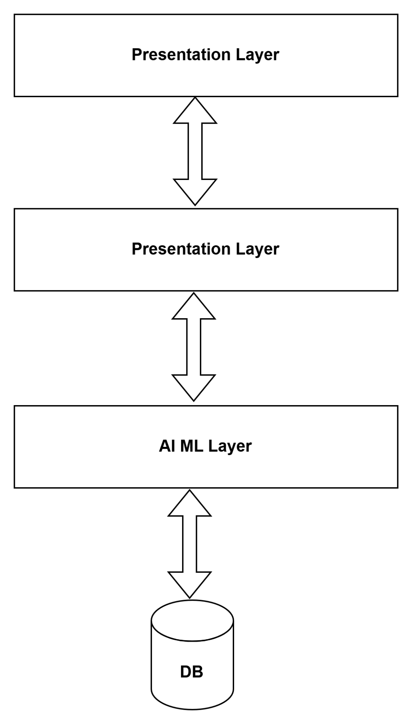

📦 Technology Components

1. Core AI/ML Stack
Component | Technology | Purpose | Justification
LLM | Azure OpenAI GPT-4 | Intelligent verification | Enterprise SLA, Azure integration
Embeddings | text-embedding-ada-002 | Vector generation | Cost-effective, high quality
OCR | Azure Form Recognizer | Document text extraction | Multi-language, table support
Orchestration | LangChain | RAG pipeline | Industry standard, flexible
Vector DB | ChromaDB / Azure AI Search | Knowledge base storage | ChromaDB (dev), Azure (prod)
ML Framework | Python 3.10+ | AI service development | Rich ecosystem

2. Backend Stack
Component | Technology | Purpose
API Gateway | Spring Cloud Gateway | Request routing, auth
Core ERP | Spring Boot 3.x | Business logic
AI Service | FastAPI | Python AI endpoints
Message Queue | Apache Kafka | Async processing
Cache | Redis | Session, rate limiting
Database | PostgreSQL 15 | Structured data
Object Storage | Azure Blob Storage | Document storage

3. DevOps & Infrastructure
Component | Technology | Purpose
Container | Docker | Application packaging
Orchestration | Kubernetes (AKS) | Container management
CI/CD | Azure DevOps / GitHub Actions | Deployment automation
Monitoring | Azure Monitor + App Insights | Performance tracking
Logging | ELK Stack | Centralized logs
IaC | Terraform | Infrastructure automation

Detailed System Design:
High-Level Architecture

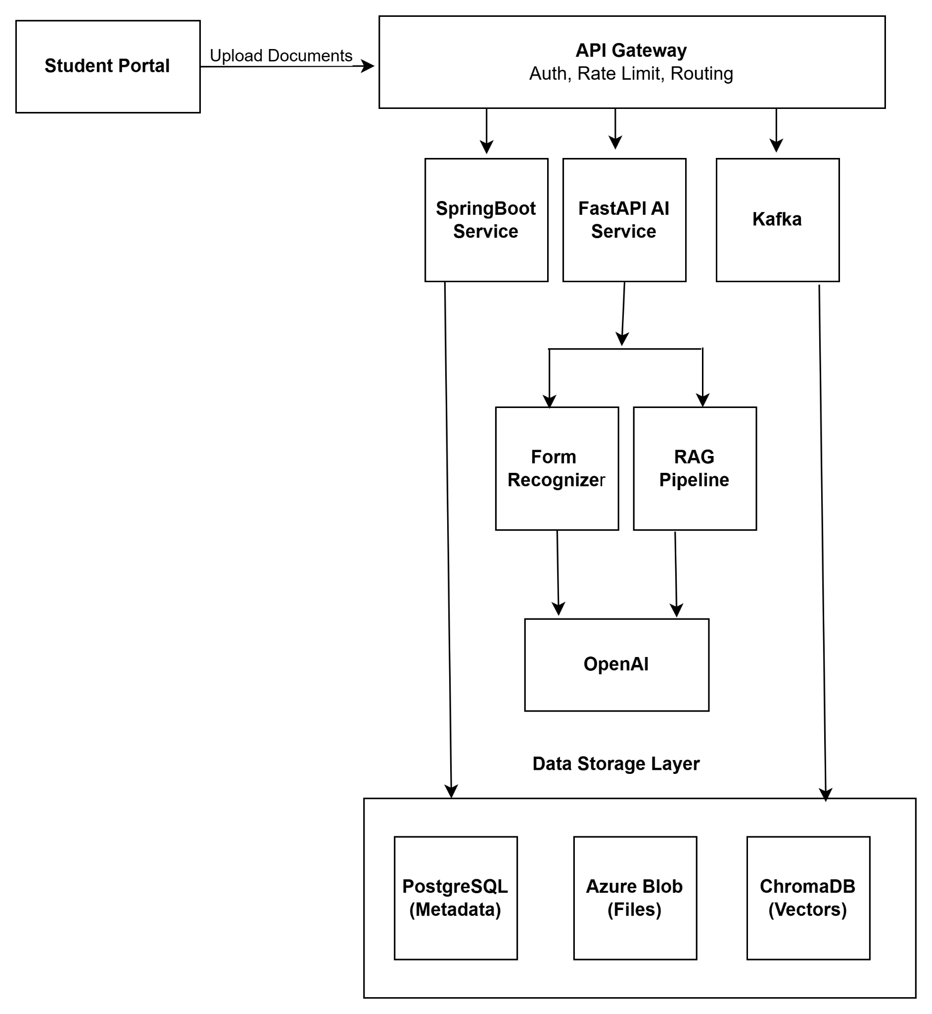

Automated document verification flowchart
